The Battle of the Neighbourhoods – Report

1.Introduction & Business Problem:

A restaurant is a business which prepares and serves food and drink to customers in return for money, either paid before the meal, after the meal, or with an open account. The City of New York is famous for its excellent cuisine. So, it is evident that to survive in such competitive market it is very important to strategically plan.

Various factors need to be studied in order to decide on the Location such as:

1. New York Population

2. New York City Demographics

3. Are there any Farmers Markets, Wholesale markets etc nearby so that the ingredients can be

purchased fresh to maintain quality and cost?

4. Are there any venues like Gyms, Entertainment zones, Parks etc nearby where floating

population is high etc

5. Who are the competitors in that location?

6. Cuisine served / Menu of the competitors

7. Segmentation of the Borough

Even though well-funded XYZ Company Ltd. need to choose the correct location to start its first

venture. If this is successful, they can replicate the same in other locations.

This would interest anyone who wants to start a new restaurant in New York city.

2. Data:

One city will be analysed in this project: New York City.

We will be using the below datasets for analysing New York city

Data 1: Neighbourhood has a total of 5 boroughs and 306 neighbourhoods. In order to segment the

neighbourhoods and explore them, we will essentially need a dataset that contains the 5 boroughs and the neighbourhoods that exist in each borough as well as the latitude and longitude coordinates of each neighbourhood.

Data source: <https://cocl.us/new_york_dataset>

Description: This data set contains the required information. And we will use this data set to explore various neighbourhoods of New York city.

**Date 2: Indian restaurants in each neighbourhood of New York city.**

Data source: Foursquare API

Description: By using this api we will get all the venues in each neighbourhood. We can filter these venues to get only Indian restaurants.

Data 3:GeoSpace data

Data source: https://data.cityofnewyork.us/City-Government/Borough-Boundaries/tqmj-j8zm

Description: By using this geo space data we will get the New York Borough boundaries that will help us visualize choropleth map.

Analysis

### Analysis

We will import the required libraries for python.

* pandas and numpy for handling data.
* request module for using FourSquare API.
* geopy to get co-ordinates of City of New York.
* folium to visualize the results on a map

Results

1.We see that Queens has the highest number of Neighbourhoods.

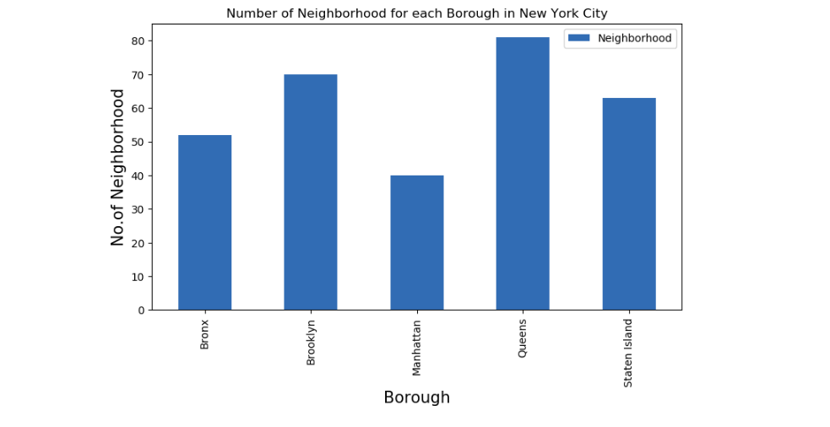

2. Also Queens has the highest number of Indian Restaurants.

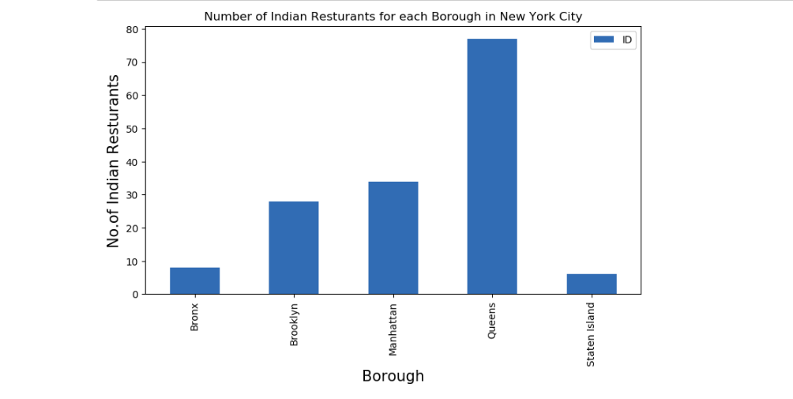

3. Floral Park in Queens has the highest number of Indian Restaurants with a total count of 9.

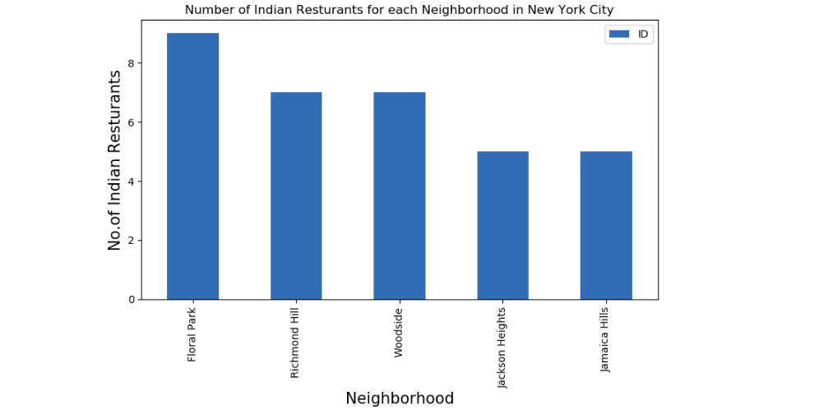

4. Manhattan has the highest average rating for Indian Restaurants.

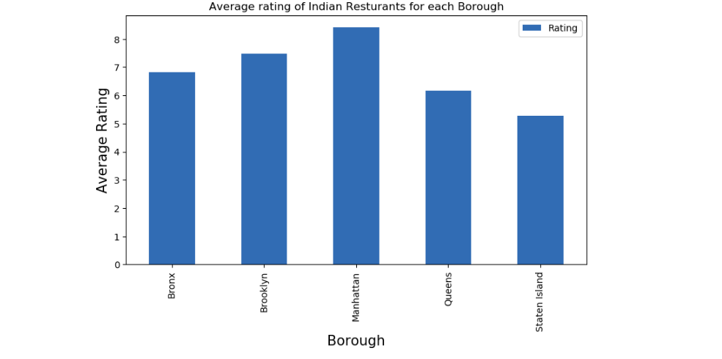

5. Best neighbourhoods in New York that has highest average rating for Indian Restaurants.

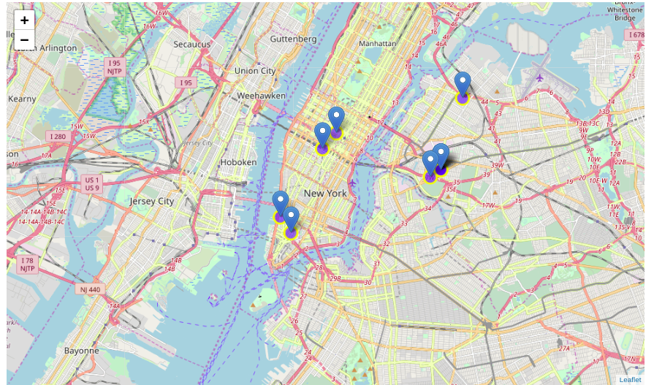

6. Borough Choropleth map based on average rating of Indian Restaurants.

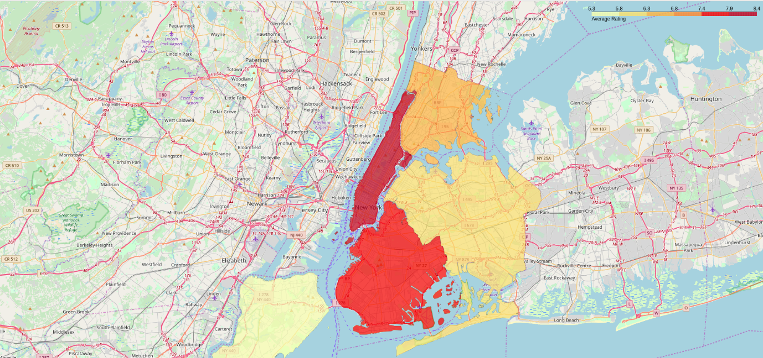

Conclusion:

1. Astoria(Queens), Blissville(Queens), Civic Center(Manhattan) are some of the best neighbourhoods for Indian cuisine.

2. Manhattan have potential Indian Restaurant Market/

3. Staten Island ranks last in average rating of Indian Restaurants.

4. Manhattan is the best place to stay if you prefer Indian Cuisine.

* NOTE - The ranking is purely on basis of rating of restaurants
* The accuracy of data depends purely depends on the data provided by FourSquare